Teacher Notes for “Levels of Organization in Biology”

This activity uses the example of a flock of pelicans in flight to illustrate how analysis at multiple levels of organization enhances our understanding of a biological phenomenon. Through an interactive whole-class discussion of PowerPoint slides, students learn about the multiple levels of organization in biology, as well as reductionism and emergent properties. To reinforce these concepts, students answer the questions in a Student Handout and discuss their answers in additional whole class discussions.

This activity is intended to follow our Characteristics of Life activity (https://serendipstudio.org/exchange/bioactivities/lifecharacteristics).

These Teacher Notes include:
- Learning Goals, page 1
- Instructional Sequence and Suggestions, pages 1-5
- Biology Background, pages 5-8
- Additional Resources, pages 8-9

Learning Goals
In accord with the Next Generation Science Standards:
- This activity helps students to prepare for Performance Expectation HS-LS1-2. “Develop and use a model to illustrate the hierarchical organization of interacting systems that provide specific functions within multicellular organisms.”
- Students learn the Disciplinary Core Idea LS1.A. “Systems of specialized cells within organisms help them perform the essential functions of life. … Multicellular organisms have a hierarchical structural organization, in which anyone system is made up of numerous parts and is itself a component of the next level.”
- Students engage in the Scientific Practice, “Developing and Using Models. Develop, revise, and/or use a model based on evidence to illustrate and/or predict the relationships between systems or between components of the system.”
- This activity helps students to understand the Crosscutting Concept, “Systems and System Models. Systems may interact with other systems; they may have subsystems and be part of larger complex systems.”

Instructional Sequence and Suggestions
1. Whole class discussion of the Levels of Organization in Biology PowerPoint (available at https://serendipstudio.org/exchange/bioactivities/LevelsOrganization).

Show slide 1. You may want to begin by asking your students, “What is biology?” Students should remember from the “Characteristics of Life” activity that biology is the study of living things.

Ask your students “What do you think is included in the biosphere?” The biosphere consists of all the living things on earth and the parts of the earth they live in, including oceans and other bodies of water, land (to a depth of several kilometers), and the atmosphere (to a height of several kilometers).

Point out the distinction between ecosystem and community, and ask your students:
- “What other organisms are in this community?” Guide the discussion to include at least fish (which the pelicans eat) and algae (which grow in the water and provide food for the fish).
- “What aspects of the environment are important for the organisms that live in this community?” Guide the discussion to include water (where the fish live), air (which the pelicans breathe and use for flight), and sunshine (which provides the energy for photosynthesis in the algae).

Ask your students “How does a bird fly?” Typically, the first answers to this question are something about the birds flapping their wings. Point out that the bird can fly because of smaller parts (e.g. wings). Then, dig deeper; ask “How do the wings work?” Expect answers, and dig for answers, about the brain, nerves, nerve cells, muscles, etc. Students may also mention feathers and bones. (See figure below.)
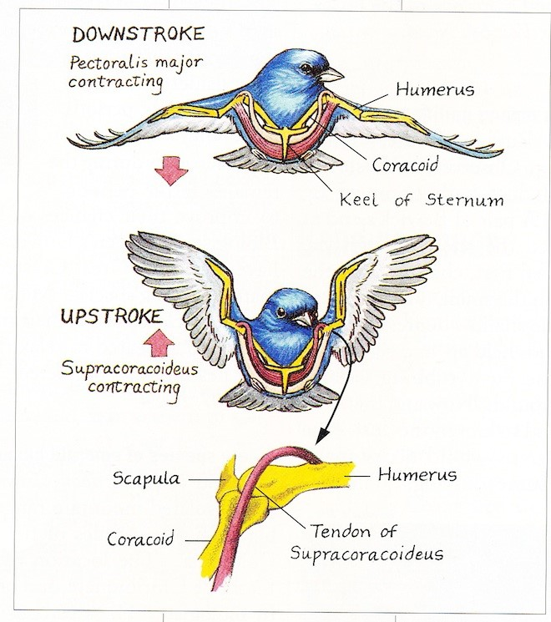
(https://www.birdwatchingdaily.com/news/science/the-amazing-muscles-and-bones-that-make-birds-fly/)

Show slide 2. Ask your students “What is included in the nervous system?” Their answers should include at least the brain, the spinal cord, and the nerves to muscles. Ask “How do you think that each part of the nervous system contributes to flight?” The brain generates the pattern of activity that travels via the spinal cord and nerves to stimulate the wing muscles to contract in the cyclic pattern required for flight.

Ask your students “What is an organ?” An organ is a body part that consists of multiple kinds of cells and carries out a specific function or functions. A tissue is a group of cells that have a similar structure and function. For example, nervous tissue is made up of nerve cells. Remind students of the principle that form matches function, and ask students “Why would it be useful for some nerve cells to have the long shape shown?” If needed, use the diagram of the nervous system in the flying pelican to help students realize that long axons are needed to transmit signals down the spinal cord and out to the muscles.

You may want to remind your students that cells are made up of molecules. You may want to ask your students “Why does a cell need DNA?” Remind them that the DNA inside the nucleus provides the instructions to make the proteins that cells need to function. Examples of needed proteins include structural proteins that maintain the shape of nerve cells and protein enzymes that produce the chemical messengers that nerve cells use to communicate with other nerve cells or muscles.

Ask your students whether wings by themselves without the rest of the bird can fly. Guide your students to understand that the characteristic of flight is a property of the larger system (a bird). However, to understand how a bird flies we need to look at smaller components; for example, scientists have analyzed how the wings move during flight, how the wing muscles’ activity results in the wings’ movement, and how the brain generates a pattern of activity that the nerves carry to the wing muscles to stimulate the pattern of wing muscle activity that produces flight.

Show slide 3 and discuss why biologists study all the multiple levels of organization introduced in slides 1 and 2. You may want to explicitly introduce the concepts of emergent properties and reductionism.

Emergent properties are properties that are only observable at a larger level of organization and not in the component parts. Emergent properties are sometimes summarized as: The whole is greater than the sum of its parts. (A useful analogy could be a comparison between a working bicycle and a box with all the parts from the bicycle.)

Reductionism is the analysis of a complex system by studying its smaller, component parts, how each part works, and how they work together. In other words, understanding how “X” works means understanding the smaller components of “X”, how each component functions, and how they cooperate. Reductionism has been a very important strategy for developing scientific understanding. (A useful analogy could be figuring out how to fix a bicycle by checking out each part and how it is working and interacting with the other parts.)

Scientific understanding requires both reductionism and the study of emergent processes. Scientists can best understand a biological phenomenon by analyzing it at multiple levels.

To extend our analysis of bird flight and levels of organization in biology, introduce the observation that, during flight, both breathing rate and heart rate increase substantially. Ask your students why a bird’s breathing rate and heart rate increase when it is flying. Students may not be familiar with cellular respiration but they should know that oxygen is needed to provide the energy needed for muscle contraction. Show slide 4 and ask students “How does oxygen get from the air to a bird’s wing muscles?” Probe for answers at multiple levels: organ systems, organs, tissues, cells, and molecules. Guide students to volunteer answers such as:
- respiratory system, circulatory system
- lungs, heart
- blood, muscle tissue
- muscle cells in the heart, red blood cells
- hemoglobin, DNA.

Show slide 5 and explain that each labeled part (other than the heart) shows the location of small blood vessels where molecules like oxygen can move into or out of the blood. Ask your students to use the figure as a basis for explaining how oxygen gets to the wing muscles. Blood is pumped by the heart through blood vessels to all the organs in the body. Blood picks up oxygen as it passes through the small blood vessels in the lungs and blood gives off oxygen as it passes through the small blood vessels in the wing muscles, etc. Next, ask your students, “Can any of the parts of the circulatory system acting alone bring oxygen to the wing muscles?” Once again, point out how analyzing a biological system at multiple levels leads to a more complete understanding of a biological phenomenon.

Show slide 6 and distribute the Student Handouts. Discuss the definitions and examples given in slide 6 and question 1 of the Student Handout.

In discussing the plant column, you may want to ask your students to name other plant organs in
addition to leaves (stems and roots). The plant tissue shown is found in leaves (see figure on page 7). It consists of a double layer of cells like the one in this figure. The main function of these cells/this tissue is photosynthesis.  The cell components that are found in both plant cells and animal cells include the cell membrane, nucleus and cytoplasm. The components that are found in plant cells, but not animal cells, are the cell wall, chloroplasts, and the large vacuole. | 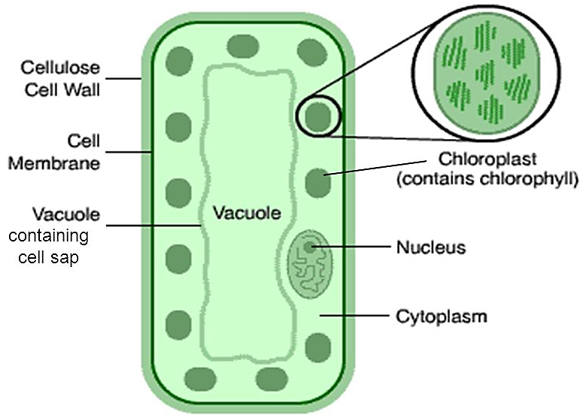  (https://images.slideplayer.com/22/6458644/slides/slide_5.jpg)

Point out that the cell is defined as the “Smallest unit that is alive”. Ask your students which characteristics of life are present in the cell, but not in molecules. Guide them to answers such as acquires and uses energy (e.g. photosynthesis), maintains homeostasis (e.g. water balance), and reproduction (e.g. mitosis), in addition to the obvious “made of cells”.

2. Student Handout (available at https://serendipstudio.org/exchange/bioactivities/LevelsOrganization)
To reinforce and extend student learning, have your students complete the Student Handout individually or in pairs. If your students are learning online, we recommend that they use the Google Doc version of the Student Handout available at https://serendipstudio.org/exchange/bioactivities/LevelsOrganization. If you are using the Word version of the Student Handout to make revisions, please check the PDF version to make sure that all figures and formatting are displayed properly in the Word version on your computer.

A key is available upon request to Ingrid Waldron (iwaldron@upenn.edu). The following paragraphs provide additional instructional suggestions and background information – some for inclusion in your class discussions and some to provide you with relevant background that may be useful for your understanding and/or for responding to student questions.

To maximize student participation and learning, I suggest that you have your students work individually or in pairs to complete each group of related questions (e.g. questions 1-6 and 7-8) and then have a class discussion after each group of questions. In each discussion, you can probe student thinking and help them develop a sound understanding of the concepts and information covered before moving on to the next group of related questions.

Questions 2-3 will guide students in thinking about how the characteristics of life emerge at the level of the cell. For example, the ability to maintain homeostasis or obtain and use energy depends on the way molecules are organized and interact within a cell (as a cell membrane, contractile vacuoles, pseudopods, food vacuole, or mitochondria). Scientists cannot predict how cells function just by studying the individual molecules in a cell. The main reason is that the molecules in a cell are highly organized and interact in specific ways that allow the characteristics of life to emerge. Hence, being alive is an emergent property at the level of the cell. You may want to ask your students, “If molecules are not alive, why do biologists study DNA, proteins, etc.?”

The definitions of the various levels of organization in biology are somewhat different in questions 1 and 7, but the meanings are similar. When students are answering question 8, they should use the information in question 3 to realize that amoebae do not have tissues, organs or organ systems.

Biology Background
The coastal ecosystem shown in slide 1 includes the water, sand, air and multiple organisms that live in the water and in and on the sand. In the water and the sand, photosynthesis is carried out primarily by microscopic cyanobacteria (blue-green algae) and single cell eukaryotes. Animals found in and on the sand include worms (e.g. bristle worms), crustaceans (e.g. crabs), and mollusks (e.g. clams). These animals feed on small particles (e.g. as filter feeders). They burrow to escape predators and desiccation. Many shorebirds and some of the fish in the coastal ecosystem are predators on the smaller animals. (https://php.radford.edu/~swoodwar/biomes/?page_id=677; http://www.coastalwiki.org/wiki/Sandy_shore_habitat)

Brown pelicans live in flocks along the coasts of the southern United States and as far south as northern South America. Brown pelicans dive from as high as 65 feet to catch fish in their large elastic throat pouches. After a successful dive, a couple of gallons of water drain out of the pelican’s throat pouch and the pelican swallows the fish whole. Pelicans eat fish that eat small organisms drifting in the ocean water (plankton, including cyanobacteria and small algae and crustaceans (https://www.allaboutbirds.org/guide/Brown_Pelican/lifehistory, https://en.wikipedia.org/wiki/Plankton).

The figure below illustrates how the form of a nerve cell (neuron) matches the function of a nerve cell. The dendrites receive input from multiple other nerve cells; this input determines whether a signal is sent down the long axon. When signals reach the end of the axon, the branching structures at the end of the axon release a chemical signal which stimulates other neurons or, in some cases, muscle cells or glands.

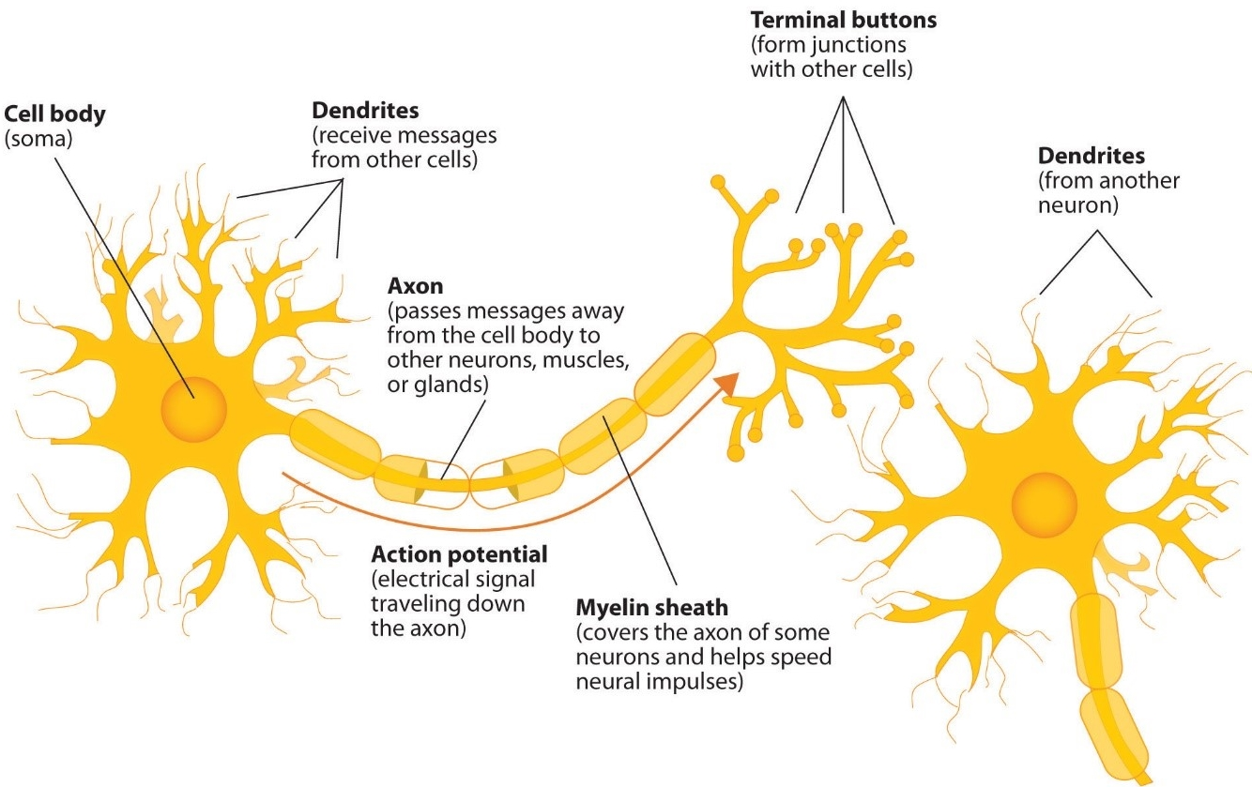
(https://2012books.lardbucket.org/books/beginning-psychology/section_07/6a3f0732c22683476ea201ffc5e428ad.jpg)

This diagram shows some important aspects of the circulatory system in birds. Blood shown in red has high levels of oxygen and blood shown in blue has low levels of oxygen. The capillaries are the tiny blood vessels where gas exchange takes place. | 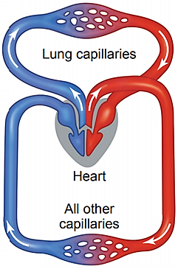

The figure in slide 6 and question 1 of the Student Handout shows a savanna ecosystem in Africa. The predominant types of vegetation are grass and trees. The animals include zebras and other grazers, giraffes (which are browsers), grasshoppers and caterpillars (which consume understory foliage), and termites (which consume dead plant matter). A savanna ecosystem typically occurs in warm to hot climates, with alternation between rainy and dry seasons. During the dry seasons, fire is common. (https://www.britannica.com/science/savanna)

The plant tissue shown in slide 6 and question 1 is a palisade mesophyll, which has cells with chloroplasts that carry out photosynthesis. | 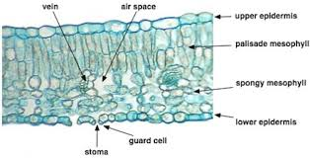  Cross-Section of a Leaf

This figure shows some of the large variety of organisms that can be found in a pond ecosystem. A pond ecosystem also has microscopic plankton, including algae, cyanobacteria (blue-green algae), and tiny invertebrates. In the detritus (dead organic matter) at the bottom of the pond are decomposers, including bacteria. Amoebae on the bottom of the pond eat dead organic matter | 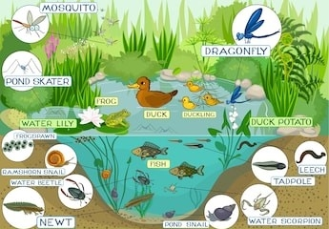  (https://image.shutterstock.com/image-vector/ecosystem-pond-260nw-320963900.jpg)
and bacteria. Abiotic components of the pond ecosystem include sunshine, water, and dissolved oxygen and minerals (https://www.caryinstitute.org/sites/default/files/public/downloads/curriculum-project/1B3_pond_ecosystem_reading.pdf; https://en.wikipedia.org/wiki/Amoeba).

This figure shows how a single cell amoeba can capture food (1), digest the food with enzymes inside a food vacuole and absorb nutrients from the food vacuole (2-4), and then expel waste products (5). | 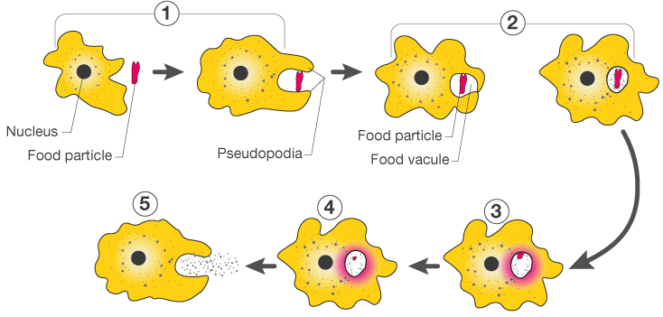  (https://cdn1.byjus.com/wp-content/uploads/2016/01/nutrition-in-amoeba1.png)

Related Activities
Structure and Function of Cells, Organs and Organ Systems (https://serendipstudio.org/exchange/bioactivities/SFCellOrgan)
In this activity, students analyze multiple examples of the relationship between structure and function in diverse eukaryotic cells, in the small intestine, and in the digestive system. Students learn that cells are dynamic, with constant molecular activity. Students analyze examples that illustrate how organelles work together to accomplish cellular functions and organs and organ systems work together to accomplish functions needed by the organism. This activity is aligned with the Next Generation Science Standards (NGSS).

Cell Membrane Structure and Function (https://serendipstudio.org/sci_edu/waldron/#diffusion)
This activity includes two hands-on experiments and numerous analysis and discussion questions to help students understand how the molecular composition and organization of a cell membrane result in its selective permeability. In the hands-on experiments, students test whether a synthetic membrane is selectively permeable and students observe how a layer of oil can be a barrier to diffusion of an aqueous solution. Then, students learn how the phospholipid bilayer and membrane proteins play key roles in the cell membrane function of regulating what gets into and out of the cell. Topics covered include ions, polar and nonpolar molecules; simple diffusion through the phospholipid bilayer; facilitated diffusion through ion channels or carrier proteins; and active transport. An optional final page introduces exocytosis and endocytosis. This activity is aligned with the Next Generation Science Standards (NGSS).

Card Sort Activity – From Coffee to Carbon available at
http://teach.genetics.utah.edu/content/cells/CoffeetoCarbon.pdf
This activity has students sort cards (each with a molecule, organelle or cell) according to size. To use this activity to reinforce student understanding of different levels of organization, we recommend that you begin by having your students sort the cards into four categories: molecules, organelles, cells, and other. After you have discussed this initial card sort, then have your students organize the cards from smallest to largest. (Depending on your students, you may want to omit some cards such as adenine, influenza virus, baker's yeast.) After students have completed the card sort by size, discuss the results and show the animation which illustrates the relative sizes (available at http://learn.genetics.utah.edu/content/cells/scale/). The order of magnitude differences in size can be used to help students realize that eukaryotic cells are made up of many many organelles and each organelle is made up of many many molecules.

Sources of Figures
PowerPoint
Slides 1 and 2, modified from https://slideplayer.com/slide/7365306/
Slide 5, modified from https://slideplayer.com/slide/8470819/26/images/17/Circulatory+System.jpg
Slide 6, modified from https://i.pinimg.com/originals/9b/60/1c/9b601c4aca761cd0c3e67e44e5c05670.jpg

Student Handout
Levels of organization figure, modified from https://i.pinimg.com/originals/9b/60/1c/9b601c4aca761cd0c3e67e44e5c05670.jpg
Amoeba figure, modified from https://cdn.thinglink.me/api/image/718903370114400257/1240/10/scaletowidth
Bird circulation figure, modified from https://slideplayer.com/slide/8470819/26/images/17/Circulatory+System.jpg

By Ingrid Waldron, Department of Biology, University of Pennsylvania, and Bradley String, Ridley High School, 2020. These Teacher Notes and the Student Handout are available at https://serendipstudio.org/exchange/bioactivities/LevelsOrganization.
Quotations are from http://www.nextgenscience.org/sites/default/files/HS%20LS%20topics%20combined%206.13.13.pdf
Some tissues, such as blood, include substantial extracellular matrix.
This figure is from https://www.brainkart.com/media/article/article-Double-circulation-Ixv.png.
The image is from https://encrypted-switch to Microsoft Outlook tbn0.gstatic.com/images?q=tbn%3AANd9GcTGUyxxoIDXFbVeimLdG6r_WeHC7c62eZ0bqtDK3M83qH-Vu4sO.
Amoebae are a diverse group of unicellular organisms with varied feeding mechanisms (https://www.sciencenewsforstudents.org/article/amoebas-are-crafty-shape-shifting-engineers).

